***THE CALCULATOR***

Using waterfall methodology

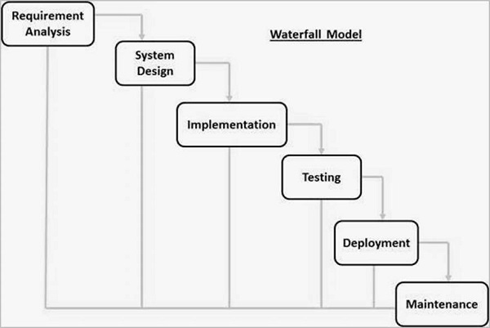

***Context model***

Input numbers x and y

Type of calculation (+,-,*,/)

System calculator

Result for calculation

User

The user inputs the two operands and the operator of which the calculator does the calculation and provides output for the user.

***Interaction model***

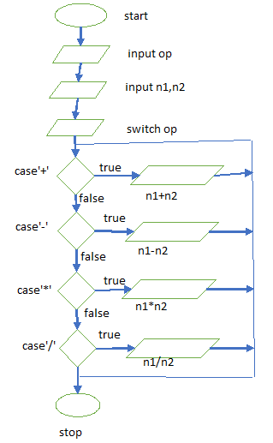

***Structural model***

Input

Data storage

Output

Arithmetic unit

***Behavioral model***

System

Transfer data

User

Their processing involves a sequence of actions on that data and the generation of an output which is displayed to the user.